

NAME: MAXWELL WAIME

ADM NO: BSCCS/2024/59239

UNIT: ADVANCED CRYPTOGRAPHY

COURSE: BACHELOR OF SCIENCE IN COMPUTER SCIENCE

DEPARTMENT: COMPUTING AND INFORMATICS

LECTURER : MICHAEL NYORO

TOPIC: WEEK 4

Table of Contents
Week 6 2
Practical Task 2
Basic SPN (Substitution-Permutation Network) Design. 2
2
Step 1: Key Mixing 2
Step 2: Substitution 3
Step 3: Permutation 3
Step 4: Ciphertext 3
PRACTICAL TASK 2 4
NON-LINEARITY INVESTIGATION 4
6
PRACTICAL TASK 3 8
SPN SECURITY EVALUATION 8
Week 7 12
Practical Task 1 12
Practical Task 2 15
Block Cipher Security Research 15
Practical Task 3 19
Security Evaluation of AES 19
Figures for Practical Task 3 21

Week 6

Practical Task

Basic SPN (Substitution-Permutation Network) Design.

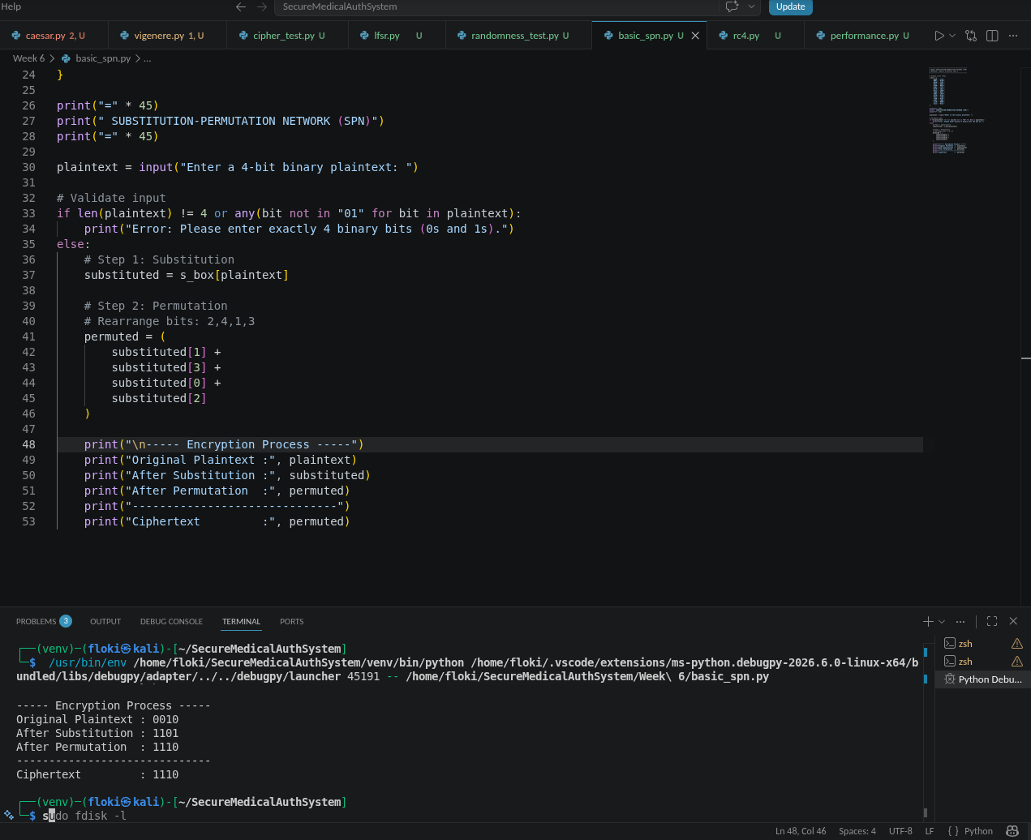
Figure 1: Basic SPN Program and execution

Explanation of the Process

Step 1: Key Mixing
The plaintext is combined with the secret key using the XOR operation. This hides the original plaintext before any further transformations.
Example:

Plaintext = 1010
Key = 0101
1010 XOR 0101 = 1111

Step 2: Substitution
The resulting bits are passed through an S-Box. The S-Box replaces one binary value with another according to predefined rules.
Example:

1111 → 0111

This introduces confusion, making it difficult to determine relationships between the plaintext and ciphertext.

Step 3: Permutation
The substituted bits are rearranged into a different order.
Example:

0111
↓
0111

Although this example does not visibly change due to the bit pattern, permutation generally spreads information across the block, creating diffusion.

Step 4: Ciphertext
The final output after substitution and permutation becomes the ciphertext.

Learning Outcome
This practical demonstrates the basic structure of a Substitution-Permutation Network (SPN). It shows how:
- XOR performs key mixing.
- S-Boxes provide confusion.
- Permutations provide diffusion.
- The combined operations transform plaintext into ciphertext.

PRACTICAL TASK 2

NON-LINEARITY INVESTIGATION
Unit: BIT4138 – Advanced Cryptography
Week: 6
Student: Maxwell Waime
Registration Number: BSCCS/2024/59239

What is Non-Linearity?
Non-linearity is a property of cryptographic algorithms where the relationship between the input and the output cannot be represented using simple linear equations. In other words, a small change in the input does not produce a predictable or proportional change in the output.
Modern encryption algorithms rely on non-linearity because predictable mathematical relationships make it easier for attackers to analyze and break encryption systems. Non-linearity introduces complexity, making it difficult to determine the encryption key even when an attacker has access to several plaintext and ciphertext pairs.
For example, in a linear system an attacker may easily derive the output from the input using simple equations. In a non-linear system, however, the output appears random, making cryptanalysis significantly more difficult.

Why is Non-Linearity Important in Cryptography?
Non-linearity is one of the most important characteristics of secure block ciphers because it strengthens the encryption process against various forms of cryptanalysis.
Its importance includes:
1. Prevents Predictable Relationships
If encryption were linear, attackers could create mathematical equations to predict ciphertext values or recover secret keys. Non-linearity removes these predictable relationships.
2. Improves Security
The complex transformations introduced by non-linearity make brute-force analysis and mathematical attacks much harder.
3. Resists Cryptanalytic Attacks
Strong non-linear functions protect encryption algorithms from:
- Linear Cryptanalysis
- Differential Cryptanalysis
- Algebraic Attacks
4. Produces Random-Looking Ciphertext
Ciphertext generated by a non-linear cipher appears random even when the plaintext contains recognizable patterns.
5. Supports the Avalanche Effect
A single-bit change in the plaintext should change many bits of the ciphertext. Non-linearity contributes significantly to achieving this property.

How Do S-Boxes Create Non-Linearity?
An S-Box (Substitution Box) is a lookup table that replaces input values with completely different output values.
Instead of using mathematical formulas, an S-Box performs substitutions based on predefined mappings.
Example:
Input | Output
0000 | 1110
0001 | 0100
0010 | 1101
0011 | 0001
Because the outputs do not follow any simple mathematical pattern, attackers cannot derive equations describing the substitution process.
S-Boxes therefore introduce confusion into the encryption process, making it difficult to determine relationships between plaintext, ciphertext, and encryption keys.

Example of Non-Linearity
Suppose two plaintext values differ by only one bit:
Plaintext 1

1010

Plaintext 2

1011

After passing through an S-Box:

1010 → 0110
1011 → 1100

Although the inputs differ by only one bit, the outputs differ significantly.
This demonstrates how non-linearity hides relationships between input and output.

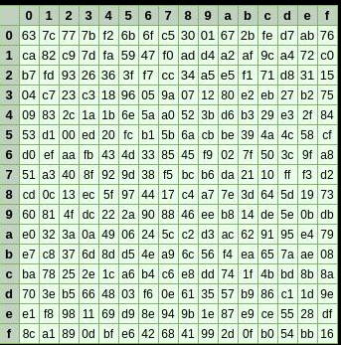
Fig 2: AES S-Box demonstrating non-linear substitution.

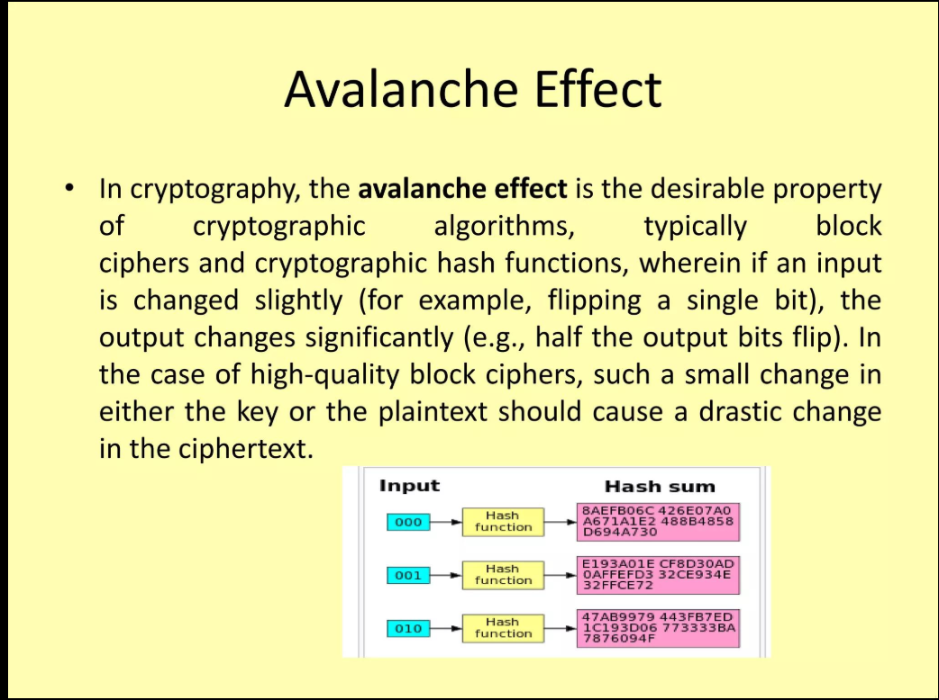
Fig 3: Illustration of the avalanche effect produced by non-linear transformations.

Applications of Non-Linearity
Non-linearity is used in many secure systems, including:
- Advanced Encryption Standard (AES)
- Banking systems
- VPN communications
- Cloud computing security
- Government information systems
- Healthcare record protection
- Secure messaging applications
These systems rely on non-linear transformations to protect confidential information from unauthorized access.

Conclusion
Non-linearity is a fundamental requirement in modern cryptography. It ensures that encryption algorithms produce unpredictable outputs and resist mathematical attacks. S-Boxes are the primary mechanism used to introduce non-linearity in Substitution-Permutation Networks such as AES. Without non-linearity, encryption algorithms would be significantly weaker and more vulnerable to cryptanalysis.

References
Stallings, W. (2017). Cryptography and Network Security: Principles and Practice (7th ed.). Pearson.
Paar, C., & Pelzl, J. (2010). Understanding Cryptography. Springer.
National Institute of Standards and Technology (NIST). (2001). Advanced Encryption Standard (AES), FIPS PUB 197.

PRACTICAL TASK 3

SPN SECURITY EVALUATION
Unit: BIT4138 – Advanced Cryptography
Week: 6
Introduction
Block ciphers are symmetric encryption algorithms that protect digital information by transforming plaintext into ciphertext using a secret key. Two of the most common block cipher structures are the Feistel Network and the Substitution-Permutation Network (SPN). This report compares these structures based on their security, performance, implementation, and modern applications.

Comparison Between SPN and Feistel Structures
Feature | SPN | Feistel Network
Structure | Operates on the entire data block | Splits the block into left and right halves
Main Components | Substitution, Permutation and Key Mixing | Round Function and XOR
Encryption | Uses multiple substitution and permutation rounds | Uses repeated Feistel rounds
Decryption | Requires inverse operations | Uses the same structure with reversed keys
Example | AES | DES

Security Evaluation
SPN
SPN structures provide very strong security because they combine substitution and permutation repeatedly over several rounds. Their use of S-Boxes introduces non-linearity, making them highly resistant to algebraic, differential, and linear cryptanalysis.
The avalanche effect is also stronger because even a small change in the plaintext causes significant changes in the ciphertext.
Feistel Network
Feistel Networks are secure when enough rounds and strong round functions are used. DES is a well-known example of a Feistel cipher.
However, older Feistel-based ciphers such as DES have become vulnerable due to shorter key lengths rather than weaknesses in the Feistel structure itself.

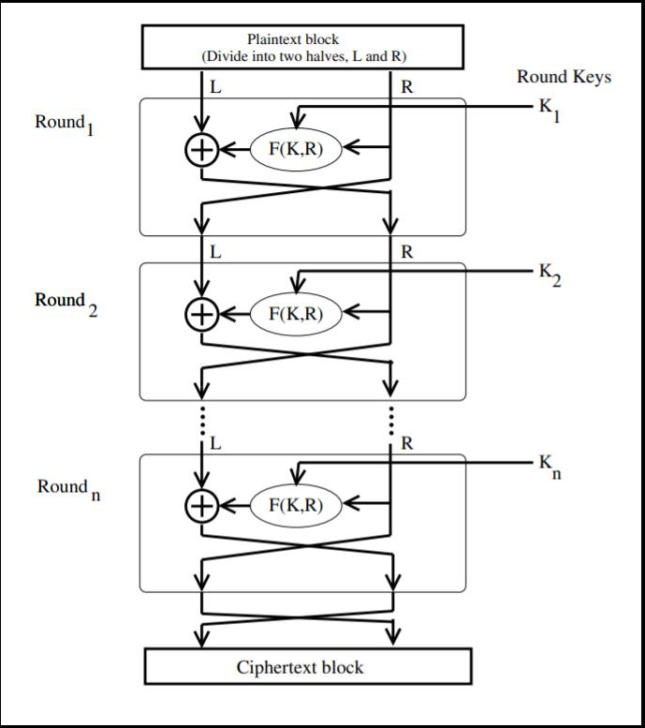
Fig 4: Structure of a Feistel Network showing left and right halves.

Performance Comparison
SPN
Advantages
- High encryption speed
- Efficient hardware implementation
- Strong diffusion
- Suitable for parallel processing
Disadvantages
- Requires inverse functions for decryption
- More complex implementation

Feistel Network
Advantages
- Simpler decryption process
- Same algorithm used for encryption and decryption
- Easy implementation
Disadvantages
- May require more rounds
- Slower diffusion compared to SPNs

Ease of Implementation
Feistel Networks are generally easier to implement because encryption and decryption use the same algorithm.
SPNs require separate inverse substitution and inverse permutation operations for decryption, making implementation slightly more complex.

Modern Usage
Today, SPN structures are more commonly used in modern encryption standards.
Examples include:
- AES
- PRESENT
- Serpent
Feistel structures continue to appear in:
- DES
- Triple DES
- Blowfish
- Twofish
Although Feistel networks remain important, SPNs are generally preferred for modern high-security applications.

Overall Evaluation
Evaluation Factor | Better Choice
Security | SPN
Diffusion | SPN
Resistance to Cryptanalysis | SPN
Ease of Implementation | Feistel
Encryption Speed | SPN
Modern Applications | SPN

Conclusion
Both SPN and Feistel structures have played significant roles in the development of block ciphers. However, SPNs provide stronger security due to their use of non-linear S-Boxes and effective permutation layers. These features offer greater resistance against modern cryptanalytic attacks, which is why AES, the current encryption standard, is based on the SPN design. Feistel Networks remain valuable because of their simple implementation and historical significance, but SPNs are generally considered the better choice for modern cryptographic systems.

Week 7

Practical Task 1
Objective
Develop a Python program that:
- Accepts two plaintext inputs.
- Computes the differences between them.
- Displays observations that illustrate the basis of differential cryptanalysis.

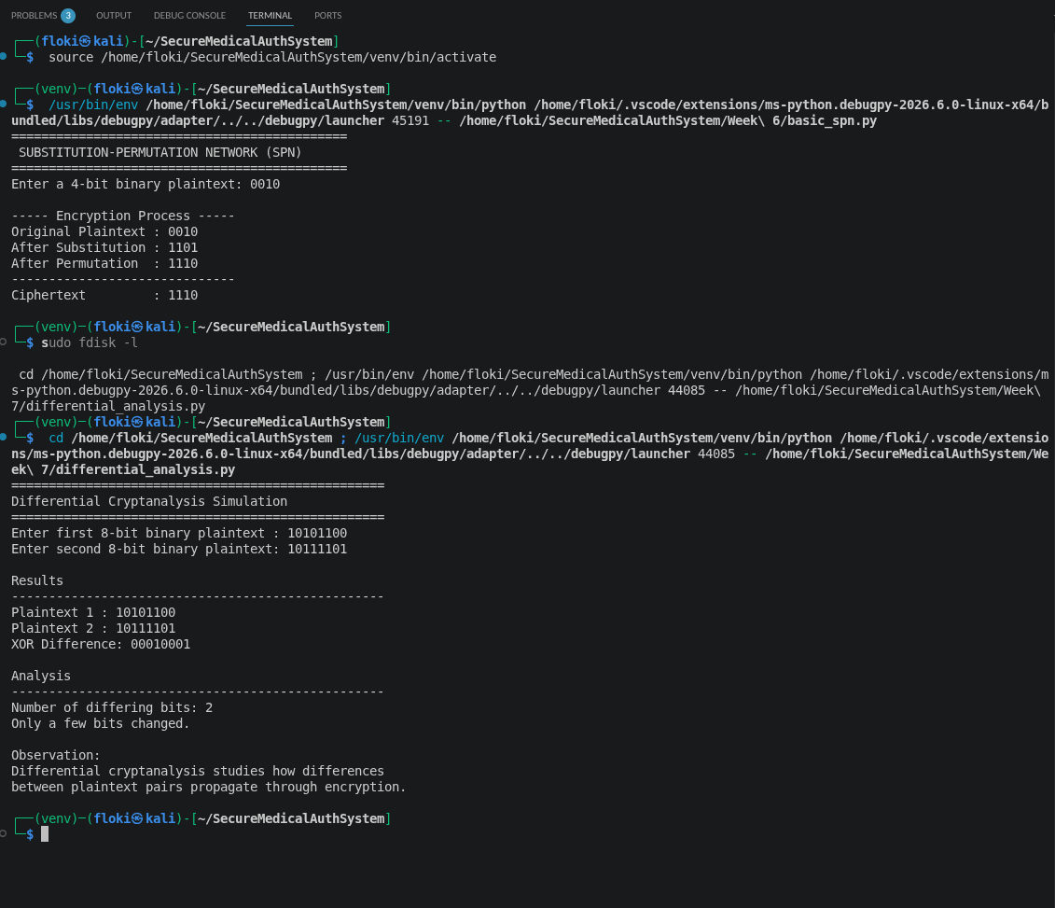
Fig 5

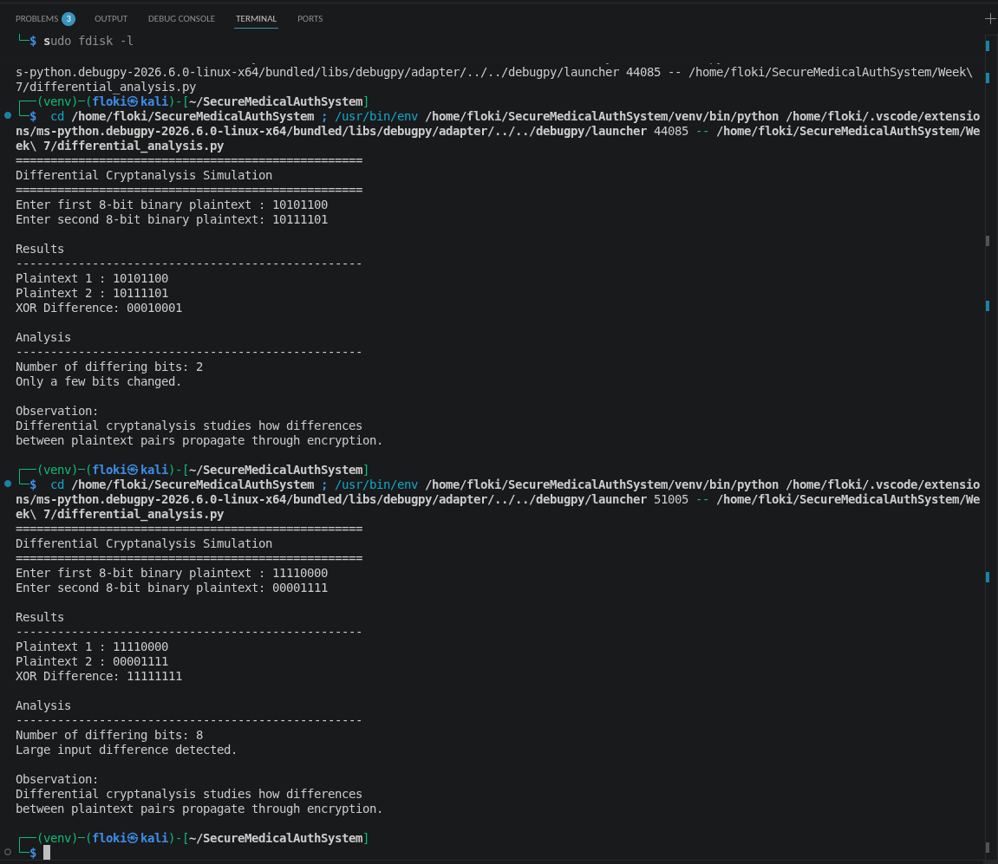
Fig. 6: Demonstration of maximum input difference between two plaintexts.

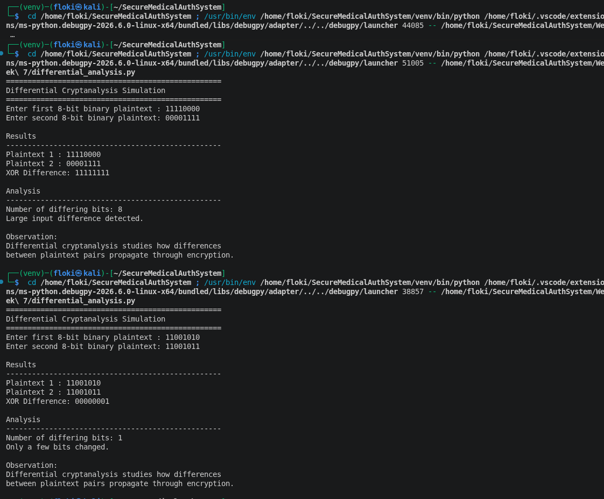
Fig. 7: Example showing a single-bit difference between two plaintext inputs.

Practical Task 2

Block Cipher Security Research
Objective
To study the major cryptanalytic techniques used to evaluate the security of block ciphers and understand why modern algorithms such as AES remain resistant to these attacks.

1. Differential Cryptanalysis
Differential cryptanalysis is a chosen-plaintext attack that examines how differences between pairs of plaintexts affect the differences in the resulting ciphertexts. By analyzing these patterns over many encryptions, an attacker attempts to recover information about the secret key.
How it works
- Two plaintexts with a known difference are selected.
- Both are encrypted using the same key.
- The resulting ciphertexts are compared.
- Statistical analysis is used to identify likely key values.
Advantages
- Effective against poorly designed block ciphers.
- Can expose weaknesses in S-Boxes and round functions.
Limitations
- Requires a large number of chosen plaintexts.
- Strong ciphers such as AES are designed to resist this attack through carefully designed S-Boxes and diffusion layers.

2. Linear Cryptanalysis
Linear cryptanalysis is a known-plaintext attack that attempts to find linear relationships between plaintext bits, ciphertext bits, and key bits.
How it works
- Collect many plaintext-ciphertext pairs.
- Identify approximate linear equations.
- Use statistical analysis to determine probable key bits.
Advantages
- Can reduce the effort required for brute-force attacks.
- Useful for evaluating cipher security.
Limitations
- Requires a very large dataset.
- Modern block ciphers minimize exploitable linear relationships.

3. Algebraic Attacks
Algebraic attacks represent the encryption algorithm as a system of mathematical equations. The attacker attempts to solve these equations to recover the encryption key.
How it works
- Express encryption operations as Boolean equations.
- Use algebraic methods to solve for unknown key bits.
Advantages
- Can be effective against algorithms with simple algebraic structures.
Limitations
- Computationally expensive.
- Strong non-linearity and complex key schedules make modern ciphers resistant.

Comparison of Cryptanalysis Techniques
Attack | Required Data | Main Idea | Effectiveness
Differential Cryptanalysis | Chosen plaintexts | Studies input/output differences | Effective against weak designs
Linear Cryptanalysis | Known plaintexts | Finds approximate linear relationships | Effective against weak linear structures
Algebraic Attacks | Cipher equations | Solves mathematical equations | Effective only when algebraic complexity is low

Why AES Resists These Attacks
AES incorporates several design features that provide strong resistance:
- Highly non-linear S-Boxes.
- Multiple rounds of substitution and permutation.
- Strong diffusion through the MixColumns transformation.
- Complex key expansion process.
- Excellent avalanche effect, where changing one input bit affects many output bits.
Conclusion
Differential, linear, and algebraic cryptanalysis are essential tools for evaluating the security of block ciphers. While they can reveal weaknesses in poorly designed algorithms, modern ciphers such as AES have been specifically engineered to withstand these attacks through strong non-linearity, diffusion, and robust key scheduling.
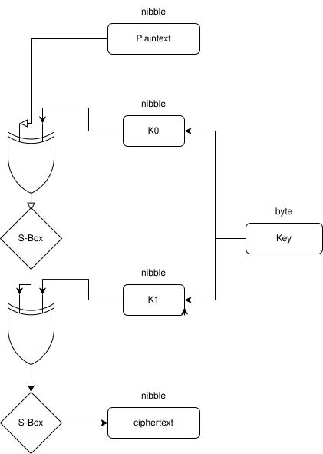
Fig 8: Conceptual representation of an algebraic attack using mathematical equations.

Practical Task 3

Security Evaluation of AES
Objective
To evaluate the security of the Advanced Encryption Standard (AES) and explain why it is widely trusted for protecting sensitive information.
Overview of AES
The Advanced Encryption Standard (AES) is a symmetric-key block cipher adopted by the U.S. National Institute of Standards and Technology (NIST) in 2001. It encrypts data in 128-bit blocks and supports key sizes of 128, 192, and 256 bits.

Security Features of AES
1. Strong Non-Linearity
AES uses a carefully designed S-Box that introduces non-linear transformations, making it extremely difficult for attackers to predict relationships between plaintext and ciphertext.
2. Confusion and Diffusion
AES combines:
- SubBytes (confusion)
- ShiftRows (diffusion)
- MixColumns (diffusion)
- AddRoundKey (key mixing)
Together, these operations provide excellent resistance to cryptanalysis.
3. Avalanche Effect
Changing a single bit in either the plaintext or the encryption key causes many bits in the ciphertext to change, making patterns extremely difficult to detect.
4. Resistance to Modern Attacks
AES is resistant to:
- Differential cryptanalysis
- Linear cryptanalysis
- Algebraic attacks
- Brute-force attacks (when appropriate key sizes are used)

Advantages of AES
- Fast and efficient.
- Strong security.
- Widely supported in hardware and software.
- Trusted by governments, banks, healthcare systems, and cloud providers.
- International encryption standard.
Limitations
- Side-channel attacks remain possible if implementations are not secure.
- AES-128 offers a smaller security margin than AES-256, though it remains secure for most applications.

Overall Evaluation
Criterion | Evaluation
Confidentiality | Excellent
Performance | Excellent
Resistance to Differential Cryptanalysis | Excellent
Resistance to Linear Cryptanalysis | Excellent
Resistance to Algebraic Attacks | Very High
Industry Adoption | Excellent

Conclusion
AES remains one of the most secure and widely used encryption algorithms available today. Its combination of non-linear substitution, strong diffusion, multiple encryption rounds, and robust key scheduling makes it highly resistant to modern cryptanalytic attacks. As a result, AES continues to be the preferred standard for securing sensitive information across industries worldwide.

Figures for Practical Task 3
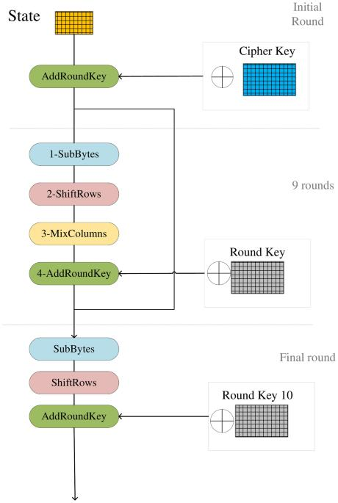
Fig. 9: The sequence of operations in an AES encryption round.
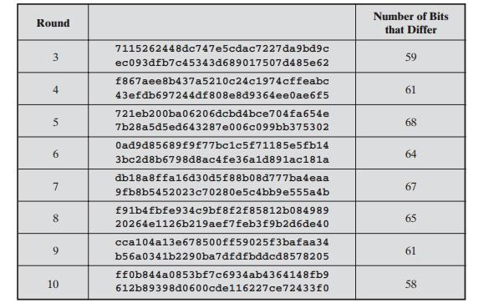

Fig. 10: Avalanche effect in AES, demonstrating how a one-bit change in input produces a significantly different ciphertext.
.

